**Guide to use postman.**

1. **FetchAllWeather:**

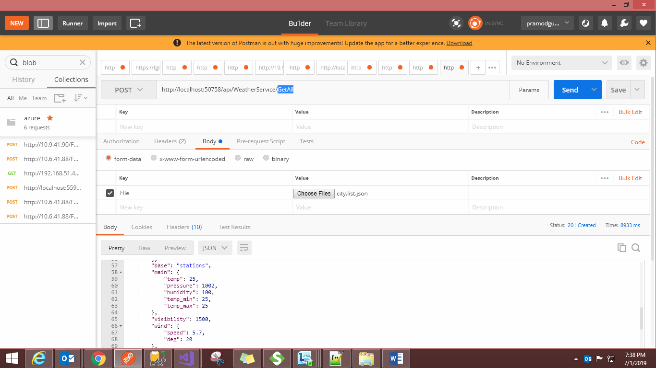

1. **FetchWeatherByID:**

